CPE301 – SPRING 2019

Design Assignment 3A

Student Name: Allis Hierholzer

Student #: 2000160356

Student Email: hierholz@unlv.nevada.edu

Primary Github address: https://github.com/acexhp/submission_da.git

Directory: Repository/cpe301/DesignAssignment/DA3A

Task:

The goal of the assignment is to modify the above codes to do the following:

1. Write a C AVR program that will display a string, random integer and floating point values on the serial terminal every 1 sec. Use a timer with interrupt for the 1 sec delay. Use a FTDI chip for serial to USB conversion.

Submission:

The following are required for successful completion of the design assignment:

a. AVR C code that has been compiled and working.

b. The C code should be well documented with explanation of every instruction.

c. A word document that contains the flow chart of the assembly code along with the snapshots of the schematics, components connected on the breadboard and screen shoots.

1. **COMPONENTS LIST AND CONNECTION BLOCK DIAGRAM w/ PINS**

* Breadboard
* Wires
* USB Cables
* ATMEGA328P XPLAINED MINI
* ATMEL STUDIO 7.0

1. **INITIAL/MODIFIED/DEVELOPED CODE OF TASK 1/A**

/*

* DA3A.c

*/

#include <avr/io.h>

#include <util/delay.h>

#include <avr/interrupt.h>

#include <stdio.h>

#define *F_CPU* 16000000UL

#define BAUDRATE 9600

#define BAUD_PRESCALLER (((*F_CPU* / (BAUDRATE * 16UL)))-1)

//Function declarations

volatile int Count;

void USART_init( unsigned int ubrr ); //calls integere

void USART_TX_string(char *data); //calls string

char outs[30];

int random_num; //creates variables

float AVOGADRO_NUM;

char string[] = "x 10^23 is Avogadro's number :)"; //creates string

char space[] = " "; //creates space

int main(void)

{

Count = 0;

TIMSK0 |= (1<<TOIE0); //sets interrupt when overflow

occurs

sei ();

TCCR0A = 0; //normal mode

TCCR0B |= (1<<CS02)|(1<<CS00); //prescaler = 1024

USART_init(BAUD_PRESCALLER); //baud prescaler

USART_TX_string("Printing...\r\n"); //shows succesful connection

while (1);

}

//int USART (RS-232)

void USART_init( unsigned int ubrr ){

UBRR0H = (unsigned char)(ubrr>>8);

UBRR0L = (unsigned char)ubrr;

UCSR0B = (1 << TXEN0);

UCSR0C = (3 << UCSZ00);

}

//send string to RS-232

void USART_TX_string(char *data) {

while (*data != '\0') {

while (!(UCSR0A & (1<<UDRE0)));

UDR0 = *data;

data++;

}

}

ISR (TIMER0_OVF_vect){ //timer0 overlfow interrupt

while (Count < 61){ //waiting

if ((TIFR0 & 0x01) == 1){ //detects overflow

TIFR0 = 0X01; //reset overlfow flag

Count++;

}

}

if (Count > 60){

USART_TX_string(string); //prints string

USART_TX_string(space); //prints space

random_num = *rand*(); //creates random number

AVOGADRO_NUM = 6.022141; //creates and store float value

*snprintf*(outs, sizeof(outs), "%3d\r\n", random_num);

USART_TX_string(outs);

USART_TX_string(space);

*sprintf*(outs, "%f", AVOGADRO_NUM);

USART_TX_string(outs);

USART_TX_string(space);

Count = 0;

}

}

1. **SCHEMATICS**

*computer*

*(to ATMEL STUDIO 7.0)*

*ATMEL*

*AVR*

*FTDI*

*CHIP*

PD0

PD1

GND

5V

RST

1. **SCREENSHOTS OF EACH TASK OUTPUT (ATMEL STUDIO OUTPUT)**

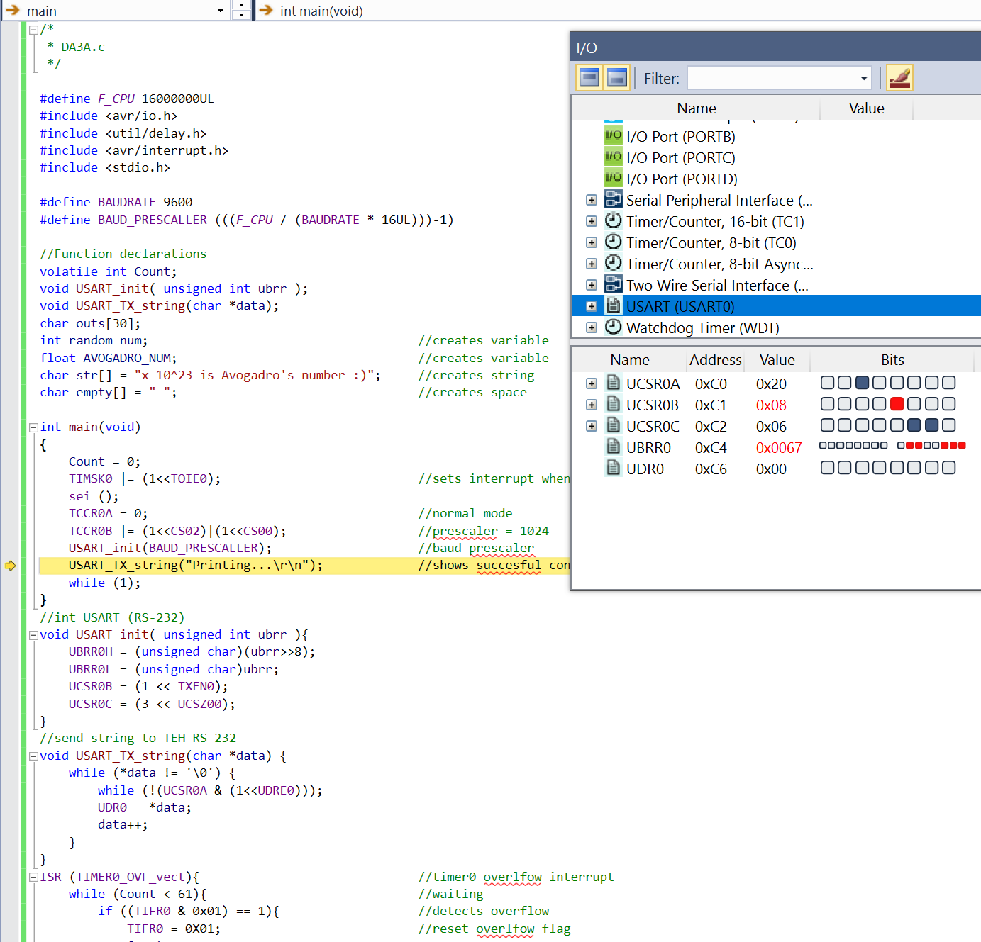

1. **SCREENSHOT OF EACH DEMO (BOARD SETUP)**

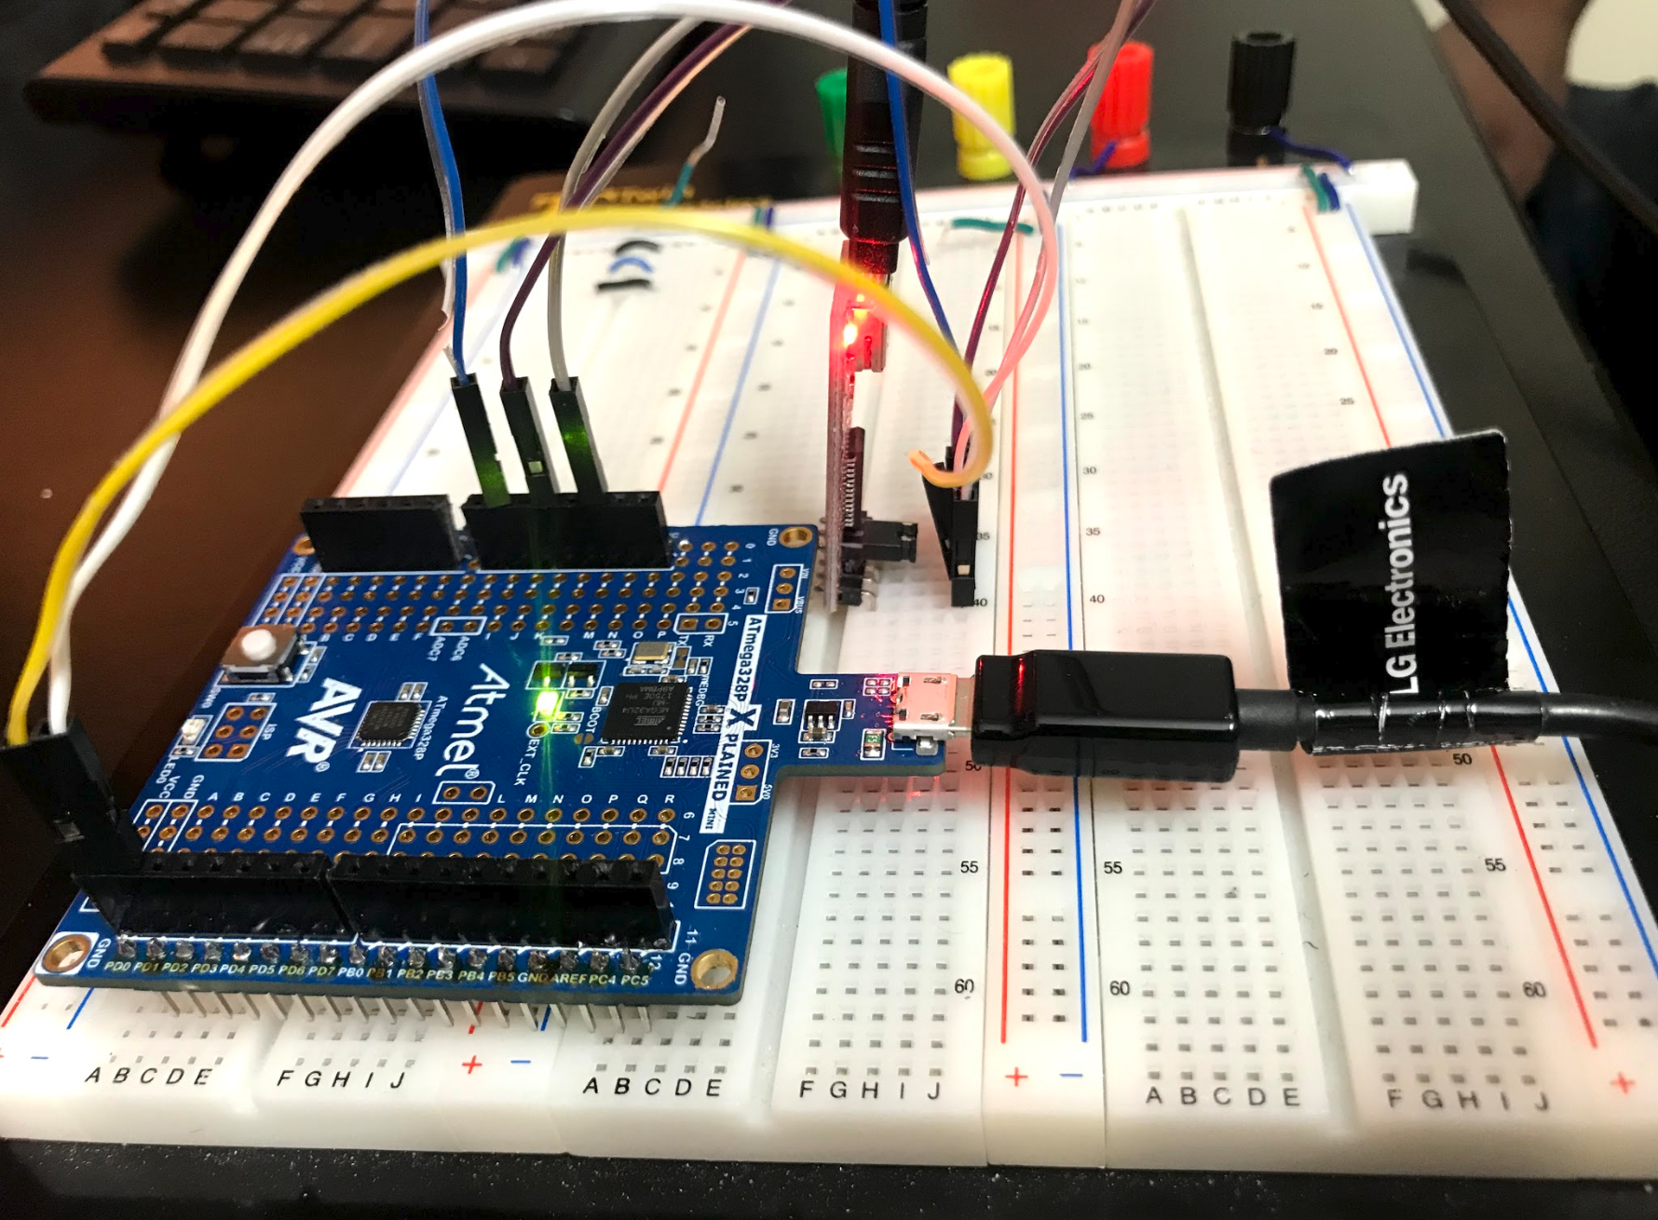

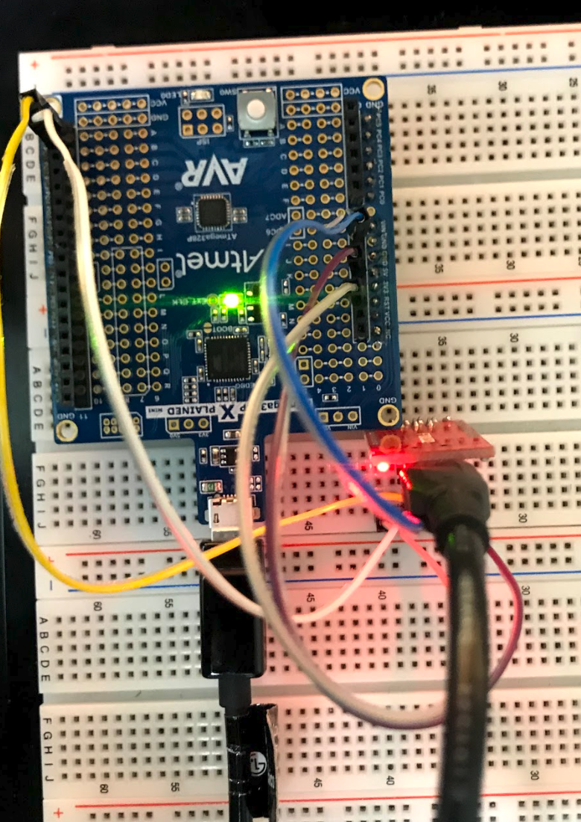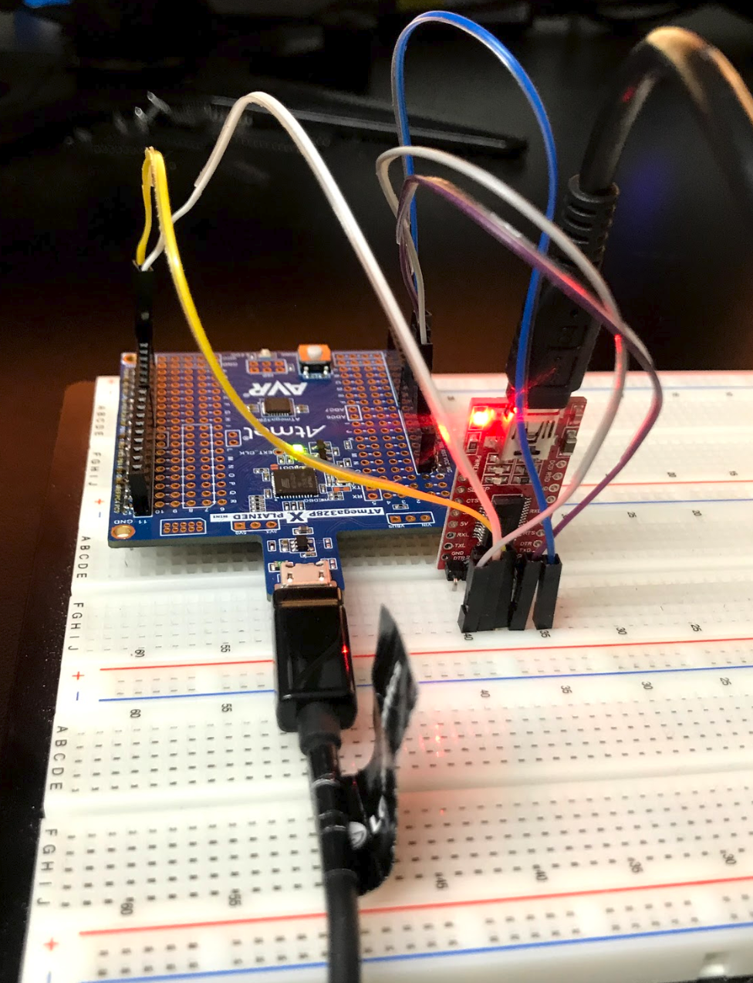

1. **VIDEO LINKS OF EACH DEMO**

[**https://youtu.be/de81e_pFMLY**](https://youtu.be/de81e_pFMLY)

1. **GITHUB LINK OF THIS DA**

<https://github.com/acexhp/submission_da.git>

**Student Academic Misconduct Policy**

<http://studentconduct.unlv.edu/misconduct/policy.html>

“This assignment submission is my own, original work”.

Allis Hierholzer